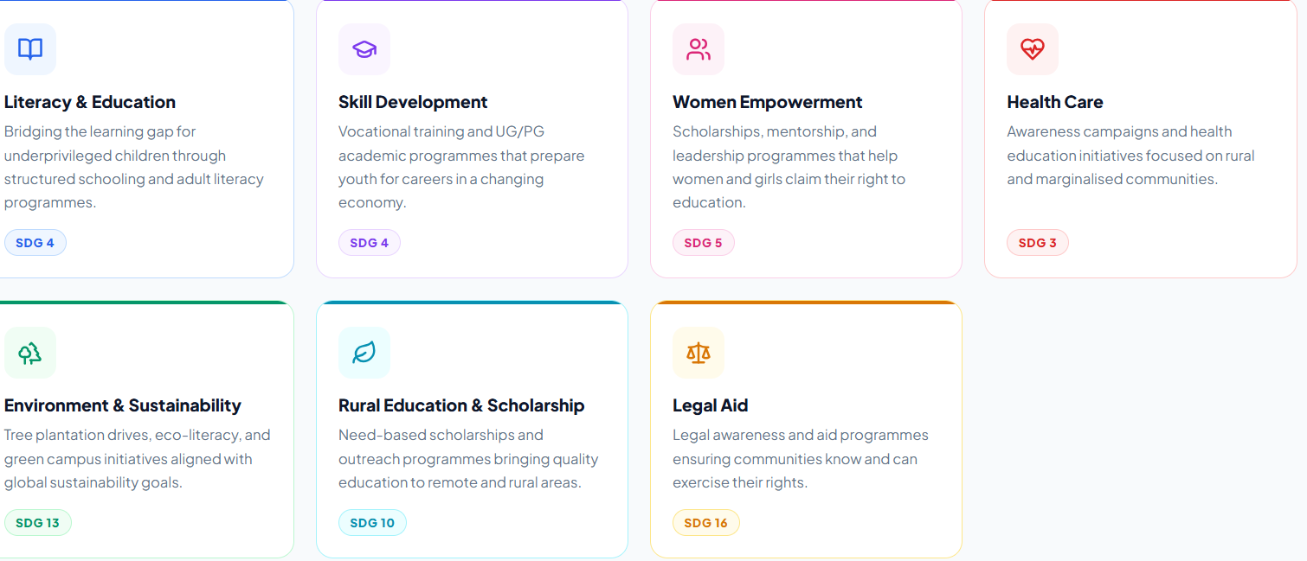
Remove from thematic areas – (environmental awareness) Add old age home welfare scheme
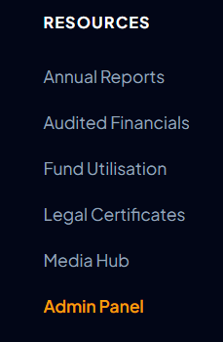
Remove Media Hub and add LEGAL TERMS AND CONDITIONS

Remove Legal Certificate and add LEGAL PRIVACY POLICY



Remove Partner with us and add BECOME A VOLUNTEER

1 – please add on IJRM and IJAQC place of programme and remove UG/ PG Programmes

